|  |  |
| --- | --- |
| LIFE logo | **HOLY CROSS COLLEGE**  **SEMESTER 1, 2016**  **Question/Answer Booklet** |

Please place your student identification label in this box

12 PHYSICS

Student Name ___________________________________

Student’s Teacher __________________________________________

#### Time allowed for this paper

Reading time before commencing work: 10 minutes

Working time for paper: 3 hours

**Materials required/recommended for this paper**

To be provided by the supervisor

This Question/Answer Booklet

Multiple-choice Answer Sheet

Data Sheet

***To be provided by the candidate***

Standard items: pens, pencils, eraser, correction fluid, ruler, highlighters

Special items: non-programmable calculators satisfying the conditions set by the School Curriculum and Standards Authority for this course

**Important note to candidates**

No other items may be taken into the examination room. It is **your** responsibility to ensure that you do not have any unauthorised notes or other items of a non‑personal nature in the examination room. If you have any unauthorised material with you, hand it to the supervisor **before** reading any further.

**Structure of this paper**

|  |  |  |  |  |  |
| --- | --- | --- | --- | --- | --- |
| Section | Number of questions available | Number of questions to be answered | Suggested working time  (minutes) | Marks available | Percentage of exam |
| Section One:  Short Answers | 14 | 14 | 60 | 64 | 30 |
| Section Two:  Problem-solving | 5 | 5 | 80 | 77 | 50 |
| Section Three:  Comprehension | 14 | 14 | 40 | 39 | 20 |
|  | | | | 180 | 100 |

**Instructions to candidates**

1. The rules for the conduct of examinations at Holy Cross College are detailed in the College Examination Policy*.* Sitting this examination implies that you agree to abide by these rules.

2. Write your answers in this Question/Answer Booklet.

3. Working or reasoning should be clearly shown when calculating or estimating answers.

4. You must be careful to confine your responses to the specific questions asked and to follow any instructions that are specific to a particular question.

5. Spare pages are included at the end of this booklet. They can be used for planning your

responses and/or as additional space if required to continue an answer.

• Planning: If you use the spare pages for planning, indicate this clearly at the top of the

page.

• Continuing an answer: If you need to use the space to continue an answer, indicate in

the original answer space where the answer is continued, i.e. give the page number.

Fill in the number of the question(s) that you are continuing to answer at the top of the

page.

6. Answers to questions involving calculations should be ***evaluated and given in decimal***

***form*.** It is suggested that you quote all answers to ***three significant figures***, with the

exception of questions for which estimates are required. Despite an incorrect final result,

credit may be obtained for method and working, providing these are ***clearly and legibly set***

***out***.

7. Questions containing the instruction *"****estimate****"* may give insufficient numerical data for their

solution. Students should provide appropriate figures to enable an approximate solution to

be obtained. Give final answers to a maximum of ***two significant figures*** and include appropriate units where applicable.

8. Note that when an answer is a vector quantity, it must be given with magnitude and direction.

9. In all calculations, units must be consistent throughout your working.**SECTION ONE: Short Answers**

**Marks Allotted: 64 marks out of 180 total.**

Attempt **ALL 14** questions in this section. Answers are to be written in the space below or next to each question.

1. Sound waves are very different from electromagnetic waves. List ***three*** differences between sound waves and electromagnetic waves. **[3 marks]**

•

•

•

2. Experimental analysis identifies a wave with a period of 1.32 x 10-15 seconds and having a wavelength of 3.95 x 10-7 metres.

(a) Calculate the speed of this wave. **[3 marks]**

(b) What is this wave most likely to be? Explain your answer. **[2 marks]**

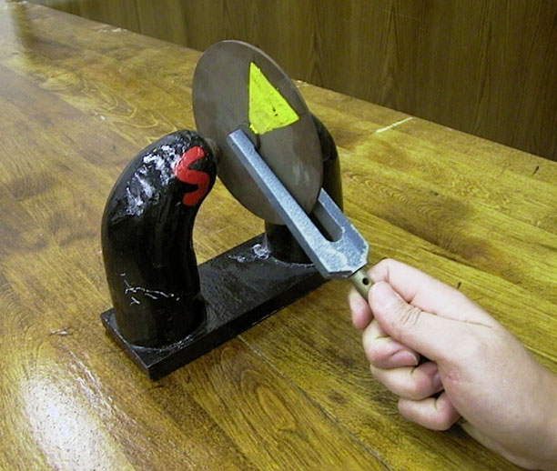3. The picture shows a rotating copper disc being moved into the magnetic field region between the north and south poles of a strong horseshoe permanent magnet.

Explain what, if anything, will happen to the rotating disc as it is held between the poles.

[5 marks]

4. Consider the diagram below showing a simple wave profile moving towards the right hand side of this page.

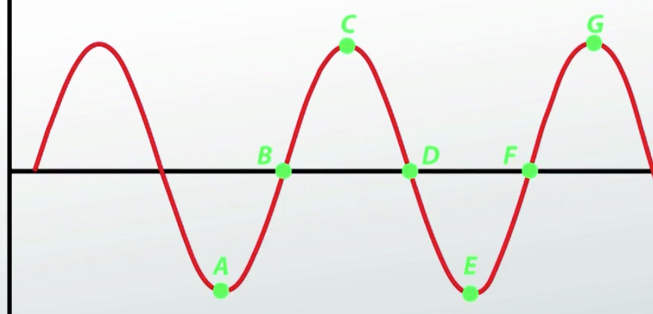

(a) On the diagram, draw arrows representing the motion of points A, C, D and F. **[2 marks]**

(b) On the diagram, show the amplitude and wavelength of this wave. **[2 marks]**

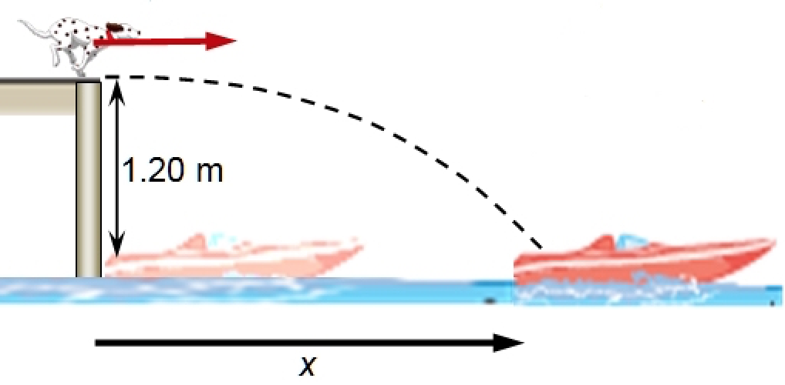5. The family dog runs horizontally off the end of the dock at a speed of 6.70 ms-1 with the intention of landing in the boat that is 1.20 m below the end of the dock.

Find the maximum horizontal displacement x that the boat can be from the end of the dock for the dog to avoid getting wet. **[4 marks]**

6. Consider the parallel plates arrangement shown here.

(a) Using at least ***six field lines***, sketch the field that exists between the plates. **[2 marks]**

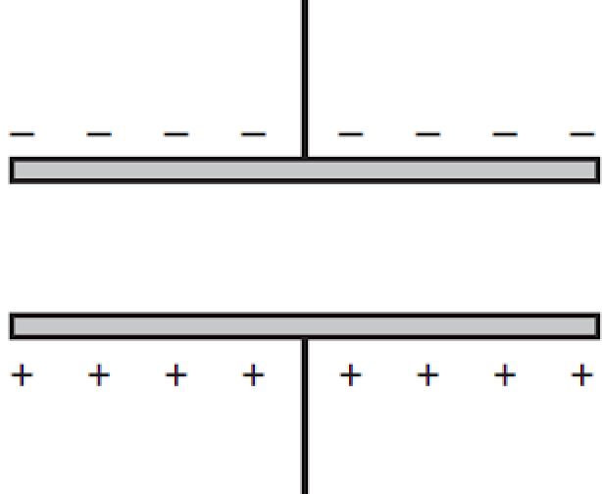

(b) Given that the plates are 1.00 cm apart and that a potential difference of 5.00 x 102 V exists between them, calculate the work done in moving a proton from the lower to the upper plate. ***(Give your answer in eV.)***  **[3 marks]**

7. An aircraft attempts to land along a north - south aligned landing strip. It approaches from the south and has an air speed of 147 kmh-1. The wind is blowing from the west at 37.0 kmh-1. Draw a vector diagram to show the direction the aircraft needs to head and calculate its actual velocity (in ms-1) relative to the runway. Show all working. **[5 marks]**

8. Use the information given in the Formulae and Data Booklet to calculate the orbital period, in seconds, of the Moon around the Earth. **[5 marks]**

9. A student is swinging a yo-yo of mass 125 g in a vertical circle of radius 0.950 m at a speed of 4.50 ms-1. Calculate the tension in the string when the yo-yo is at the lowest point of its path. **[4 marks]**

10. The diagram shows a permanent magnet being pushed ***(moving to the right)*** into a copper solenoid coil. The coil is connected to an ammeter.

(a) On the diagram, draw the direction of the induced current and the deflection of the ammeter. **[2 marks]**

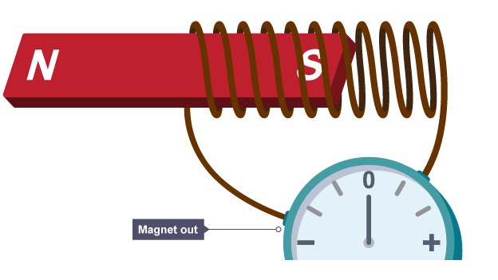

(b) List ***two ways*** that the induced current in the coil could be increased.

**[2 marks]**

•

•

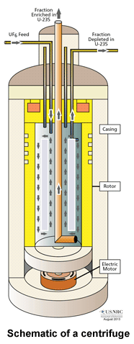11. Enrichment of nuclear fuel uses the gas centrifuge process. Many rotating cylinders (centrifuges) are connected in long lines. UF6 gas is placed in the cylinder, which spins at high speed, creating a strong "centrifugal force". Heavier U-238 gas molecules move to the cylinder wall, while lighter U-235 collects near the centre.

How fast (***in rpm***) must a centrifuge rotate if a UF6 gas molecule, located 10.0 cm from the centre of rotation, is to experience an acceleration of 1.00 x 105 "g"? **[5 marks]**

12. The picture shows the circular magnetic field created due to the movement of current in the vertical wire.

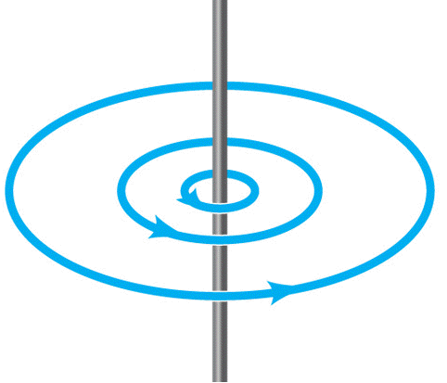

(a) On the diagram show the direction of the current.

**[1 mark]**

(b) Given that the current flowing in the wire is 5.00 A, calculate the magnetic field strength at a point 7.00 cm from the wire. **[3 marks]**

13. Aircraft flying through the Earth’s magnetic field are subject to an induced EMF across the wings.

(a) At which places on the Earth will the aircraft experience the maximum induced EMF? Explain your answer. **[2 marks]**

(b) If the maximum magnitude of the earth’s magnetic field is 5.00 x 10-5 T, calculate the magnitude of the EMF that would be induced across the wings of an Airbus A380 flying at 9.00 x 102 kmh-1. The wingspan of an A380 is 60.0 metres. **[3 marks]**

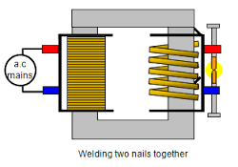

14. The transformer arrangement shown here is used to weld two iron nails together.

(a) Explain how this arrangement can produce a large enough current to fuse the nails together. State any assumptions you have made. **[3 marks]**

(b) Estimate the secondary voltage of this transformer. **[3 marks]**

**SECTION TWO: Problem Solving**

**Marks allotted: 77 marks out of 180 marks total.**

Attempt **ALL 5** questions in this section. The marks allocated to each question are given and the answers should be written in the spaces provided.

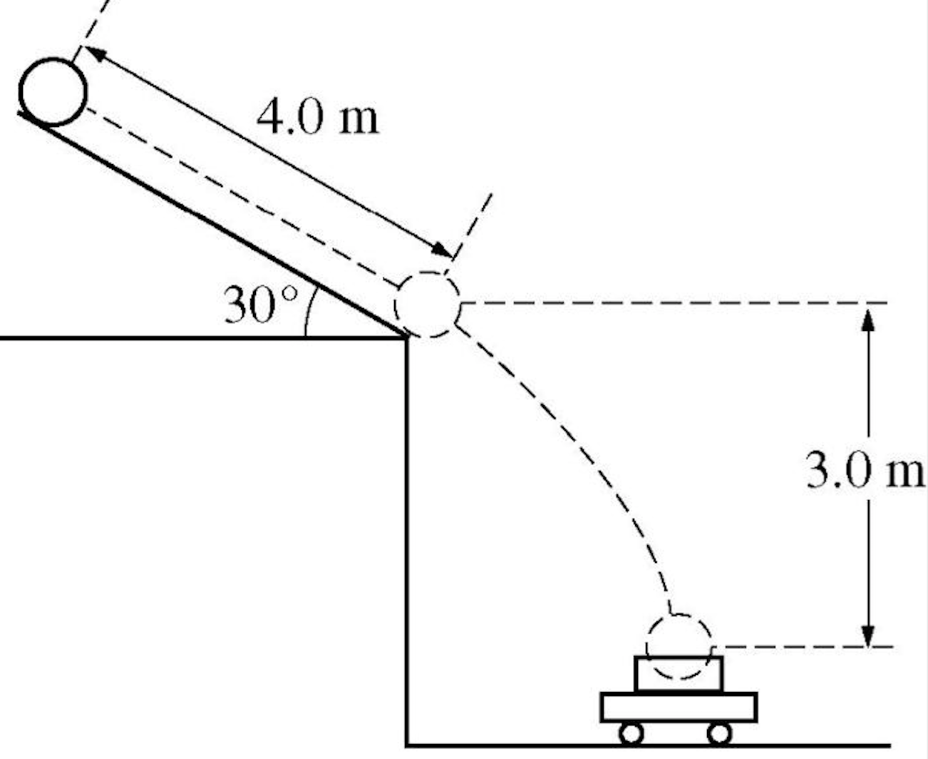**(16 marks)**

1. During a snowstorm, a large snowball rolls from the roof of a house, hitting a car parked in the driveway, as shown here.

(a) If the snowball rolls from rest, calculate the initial velocity of the snowball as it starts to fall from the edge of the roof.  **[5 marks]**

(b) How long does it take for the snowball to hit the parked car? **[6 marks]**

(c) How close is the car parked to the front of the house? **[3 marks]**

(d) List two assumptions you have made when answering this question. **[2 marks]**

•

•

**(15 marks)**

2. NASA has decided to place a satellite in orbit around the Moon to determine if any traces of water exist on, or just below, the surface.

(a) Show, by sketching a diagram, the force exerted on the satellite by the Moon as it orbits. **[2 marks]**

(b) What is the acceleration due to the moon’s gravity at a height of 2.50 x 103 km above the surface of the moon? **[4 marks]**

(c) Kepler's third law of planetary motion can be described as follows.

*"The ratio of the squares of the periods of any two planets is equal to the ratio of the cubes of their average distances from the Sun."*

This is also known as the Law of Harmonies. Show, by using the equations learned in class, that this relationship is true. **[4 marks]**

(d) If the satellite is to have an orbital period of 24.0 hours, determine the height of the orbit above the Moon’s surface. **[5 marks]**

**(16 marks)**

3. The diagram below shows a single rectangular loop of wire that is free to rotate in a uniform magnetic field of 6.00 x 10-2 T. The loop is carrying a current of 2.50 A and is

8.00 cm long and 3.00 cm wide.

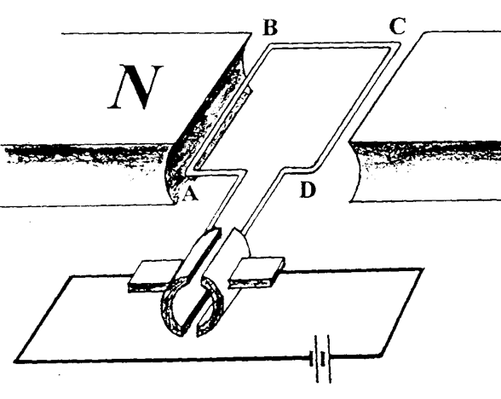

(a) On the diagram, label the brushes and split-ring commutator. **[1 mark]**

(b) Explain the function of the brushes and the split-ring commutator. **[2 marks]**

(c) On the diagram, clearly show the force acting on elements AB, BC and CD. **[3 marks]**

(d) Calculate the magnitude of the force acting on element AB. **[2 marks]**

(e) Consider the rectangular loop in its present position. What torque will be acting on the loop at present? **[3 marks]**

(f) The rectangular loop now rotates 90° from its present position in a clockwise direction. What torque now acts on the loop? Explain your answer. **[3 marks]**

(g) Using the graph paper shown below, sketch the torque on the coil as it is rotated through 360°. Take the position shown in the diagram as 0°. **[2 marks]**

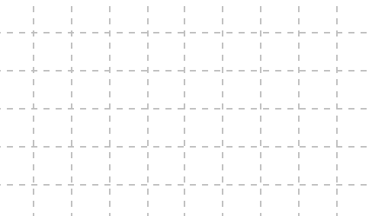

**(17 marks)**

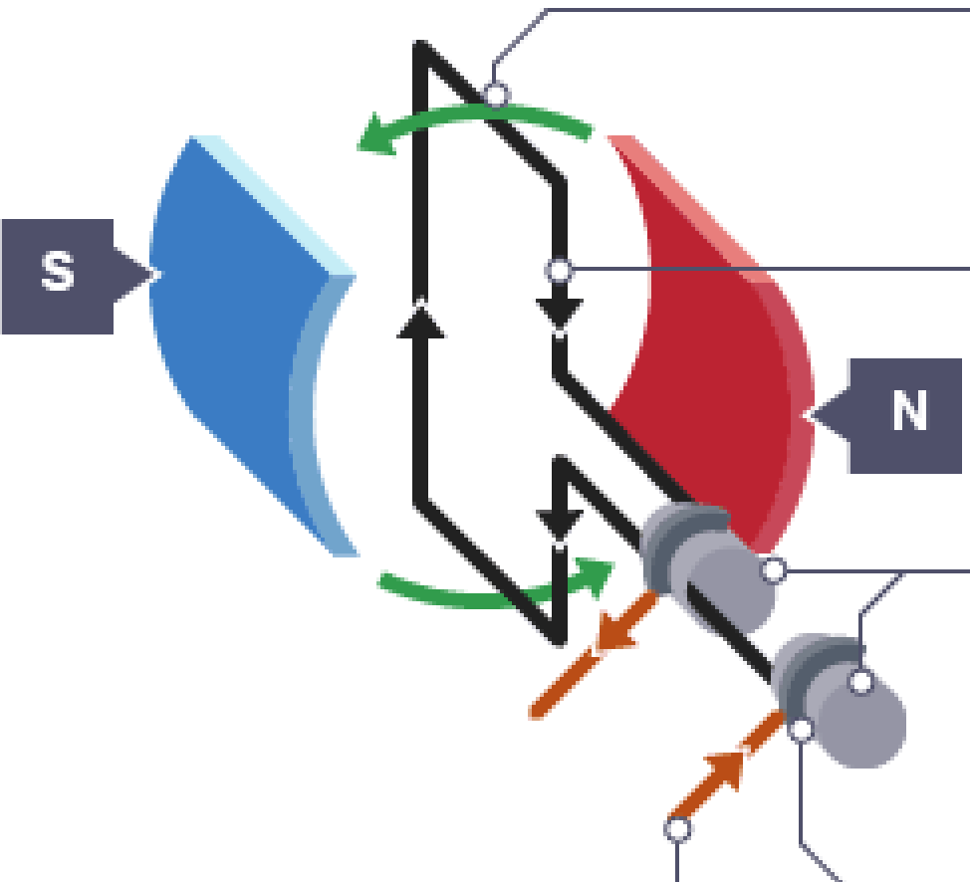

4. The diagram shown here represents an AC generator consisting of a rectangular coil with sides of 15.0 cm x 20.0 cm and 1200 turns, rotating in a uniform magnetic field. The magnetic flux through the coil in the present position is 2.50 x 10-4 Wb.

(a) Calculate the magnitude of the magnetic field strength. **[3 marks]**

(b) If the coil rotates half a revolution from the position shown, in 0.0300 seconds, calculate the magnitude of the maximum induced EMF in the coil in this time.

**[4 marks]**

(c) Explain how the EMF calculated in part (b) is produced. **[4 marks]**

(d) Using the graph paper shown below, sketch both the flux threading the coil and induced EMF generated as the coil is rotated through 360°. Take the position shown in the diagram as 0°. **[4 marks]**

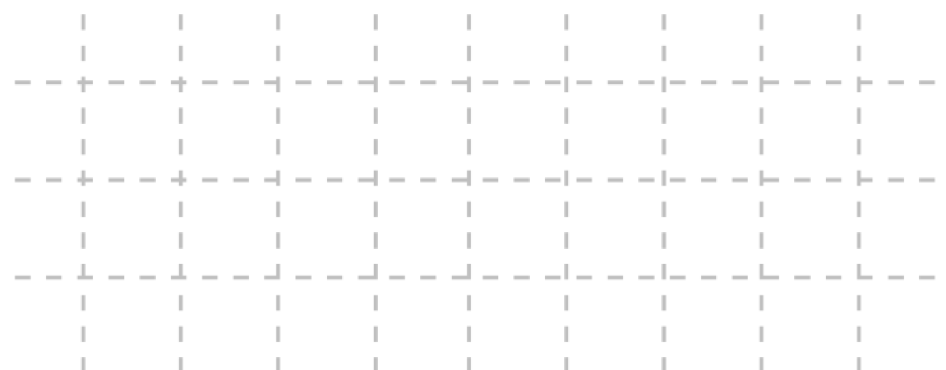



(e) Accurately draw VRMS on your graph (above). **[2 marks]**

**(13 marks)**

5. The Royal Air Force Aerobatic Team, the Red Arrows, is one of the world's premier aerobatic display teams. A typical display will involve high-speed loops, as well as high "g" banked turns.



(a) The aerobatic team drop in formation from a height of 5.00 x 102 m, forming a colourful loop. At the bottom of the loop, they are 1.00 x 102 m from the ground and feel 3.00 times their normal weight. What speed are they travelling at when they reach the bottom of the loop? **[4 marks]**

(b) Two planes break off and, using a high "g" banked turn, cross each other's path just in front of the spectators. On the diagram, draw ***accurately***, all the forces acting on this jet as it banks. **[3 marks]**

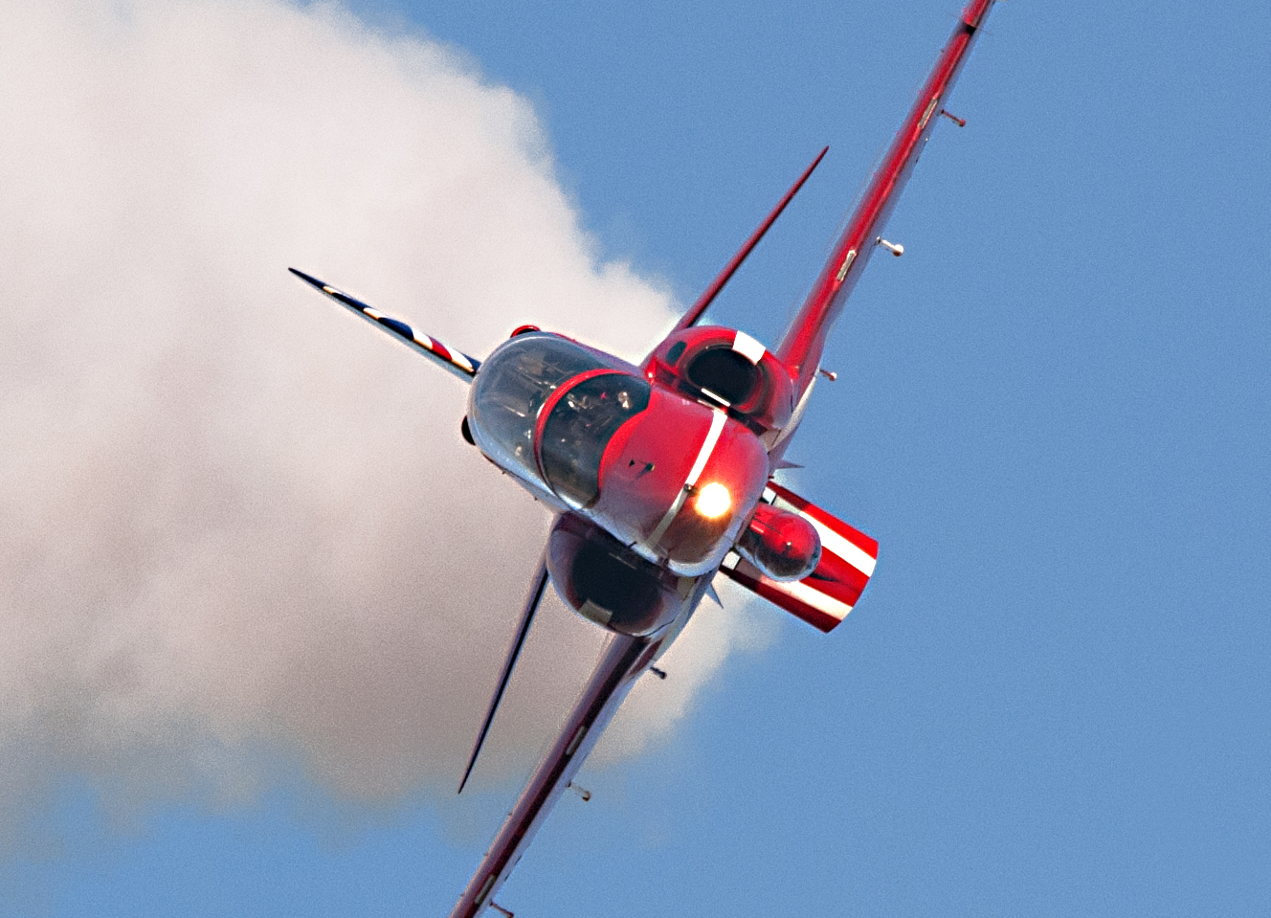

(c) In which direction is this plane banking? **[1 mark]**

(d) Given that the banking turn has a diameter of 1.00 km, ***estimate*** the speed of the jet as it makes the banked turn. **[5 marks]**

**SECTION C: Comprehension and Interpretation**

**Marks Allotted: 39 marks out of 180 marks total.**

Read the passage carefully and answer all of the questions at the end. Candidates are reminded of the need for correct English and clear and concise presentation of answers. Diagrams (sketches), equations and/or numerical results should be included where appropriate.

**Charged particles and magnetic fields**

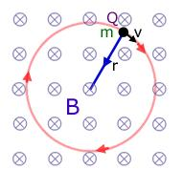

A charged particle moving in a magnetic field experiences a perpendicular force that is proportional to the strength of the magnetic field, the component of the velocity that is perpendicular to the magnetic field and the charge of the particle.

This force is known as the Lorentz force.

The Lorentz force is always perpendicular to both the velocity of the particle and the magnetic field that created it. When a charged particle moves in a static magnetic field, it will trace out a helical path in which the helix axis is parallel to the magnetic field and in which the speed of the particle will remain constant.

Since the Lorentz force is always perpendicular to the motion of the particle, the magnetic field cannot do work on an isolated charge. It can only do work indirectly, via the electric field generated by a changing magnetic field.

This phenomenon can be used in a number of useful ways:

1. To identify elementary particles.

2. To identify or categorise unknown elements.

3. As a tool to position elements precisely when building minute structures.

**Identifying elementary particles**

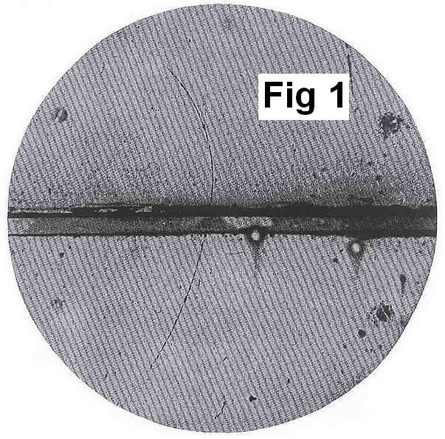

Elementary particle detectors utilise the fact that charged particles move in circular paths when they enter a magnetic field region.

The photo shows a cloud chamber photograph of the first positron ever identified. A 6 mm lead plate separates the upper half of the chamber from the lower half. The positron must have come from below since the upper track is bent more strongly in the magnetic field.

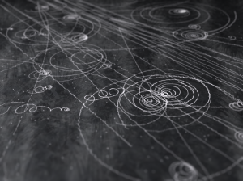Cloud chambers are used to photograph elementary particles as they pass through the detector. This allows physicists to identify particles created through high-energy collision events such as the LHC in CERN, Geneva. This picture shows the curving track of charged particles in a magnetic field cloud chamber.

**Identifying or categorising unknown elements**

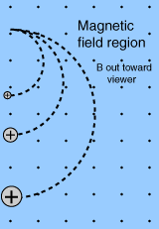Mass spectrometers are sensitive detectors of elements and isotopes based on their masses. They utilise an analytical technique that measures the mass-to-charge ratio of charged particles, making use of the Lorentz force that acts on charged particles moving in a magnetic field.

Ions are accelerated through a series of parallel plates inside a vacuum tube arrangement.

When the ions reach the electromagnet, they are deflected from their straight-line path through the action of the Lorentz force. Depending on their mass, charge, velocity and the applied magnetic field, they can be made to move in circular paths of varying radii. This allows identification by a trained technician.

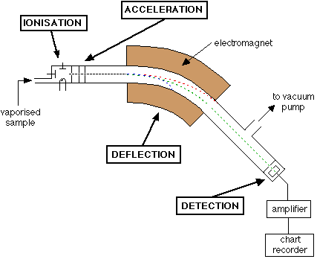

**Positioning elements precisely when building minute structures**

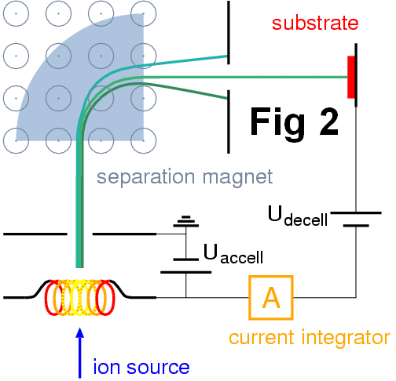

Ion implantation is an engineering process where ions of a particular type are accelerated in an electrical field, deviated and targeted by a magnetic field and impacted into a solid. This process is used to change the electrical properties of the materials and is widely used in the semiconductor device fabrication of computer chips.

The introduction of dopants in a semiconductor is the most common application of ion implantation.

Dopant ions such as boron, phosphorus or arsenic are generally created from a gas source, so that the purity of the source can be very high. These gases tend to be very hazardous. When implanted in a semiconductor, each dopant atom can create a charge carrier in the semiconductor. A hole can be created for a

p-type dopant, and an electron for an n-type dopant. This modifies the conductivity of the semiconductor in the implant area. This is what makes a semiconductor conduct.

The energy of the ions, as well as the ion species and the composition of the target, determines the depth of penetration of the ions in the substrate. Typical ion energies are in the range of 10 to

500 keV. Energies in the range 1 to 10 keV can be used, but result in a penetration of only a few nanometres or less.

Typical dopants for semiconductors:

|  |  |  |  |  |  |
| --- | --- | --- | --- | --- | --- |
|  |  | **Symbol** | **Mass (amu)** | **Charge** |  |
|  | **Boron** | B | 10.8117 | 3+ |  |
|  | **Phosphorus** | P | 30.9738 | 3- |  |
|  | **Arsenic** | As | 74.9216 | 3- |  |

***(Note: 1.00 a.m.u. = 1.66 x 10-27 kg)***

1. Explain why the Lorentz force cannot do work on a isolated charged particle inside a magnetic field B. Use mathematical formulae to help explain your answer. **[3 marks]**

2. Show that the radius of a charged particle inside a magnetic field B is given by the mathematical relationship: **[3 marks]**



3. Refer to Figure 1. Explain the statement: *‘the positron must have come from below since the upper track is bent more strongly in the magnetic field’*. **[4 marks]**

4. Determine the direction of the magnetic field in Figure 1. **[1 mark]**

The direction of the B field in Figure 1 is:

5. Why is it necessary to have a very good vacuum in a mass spectrometer? **[3 marks]**

6. Refer to Figure 2. What is the charge of the particle that hits the target substrate? **[1 mark]**

The charge of the particle that hits the substrate is:

7. Calculate the velocity of a boron ion that is fired into the substrate with the maximum typical energy. **[4 marks]**

8. The ion implanter is now reconfigured to deliver As ions into the substrate and the ion energy is reduced to produce a velocity of 8.50 x 104 ms-1. If the internal magnetic field is set to be 5.00 mT, to what radius of curvature should the machine now be set? **[4 marks]**

**THIS PAGE HAS BEEN DELIBERATELY LEFT BLANK.**

**Generation and Transmission of Electricity**

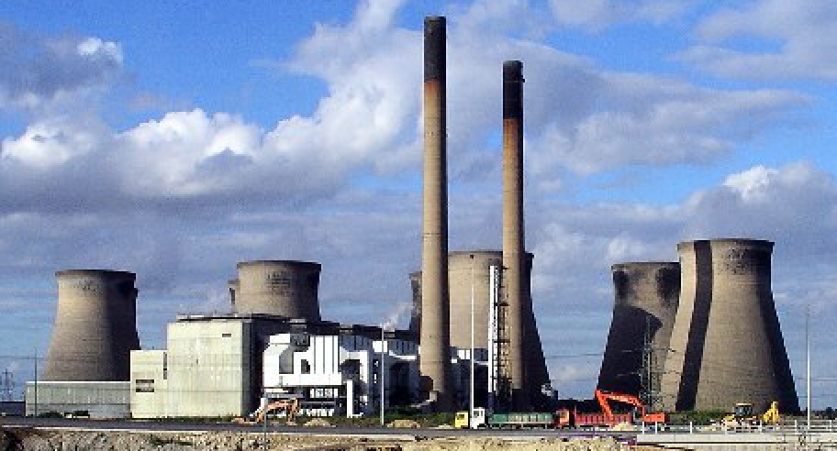

Approximately 30% of the energy used in Australia is generated by power stations. The largest power station in Western Australia is Muja, which is situated close to the coalmining town of Collie.

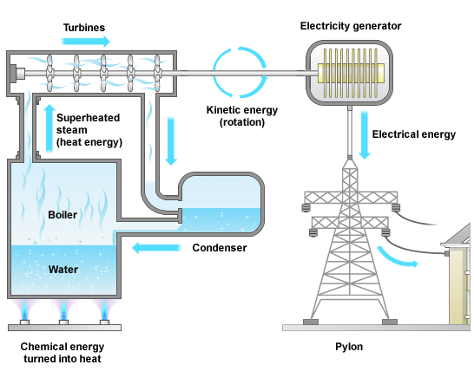

At Muja, coal is ground to the consistency of powder and then burned to heat water until it turns into steam. Steam at 540 °C and pressure of 16 MPa (megaPascals) is used to drive turbines at a rate of 3000 rpm.

Muja power station generates at a total of 1040 MW from its eight generators. There are four 60 MW generators and four 200 MW generators. The 60 MW generators produce power at 11.8 kV and the 200 MW generators produce power at 16 kV. Generators feed the electricity produced into transformers where the voltage can be stepped up or stepped down.

Before the electricity is distributed, transformers are used to step up the voltage to 330 kV. High voltage transmission has advantages in reducing energy lost due to the resistance of the transmission lines. On the outskirts of Perth, there is a substation that reduces the voltage to 11 kV and in the local park is a further small transformer that reduces the voltage to 240 volts for household use.

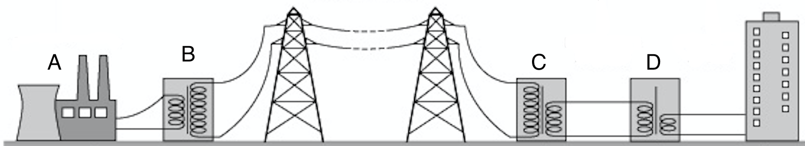

9. Using the diagram shown above, identify components A, B, C and D and describe the function they provide. **[4 marks]**

A

B

C

D

10. Explain why the generator is designed to produce alternating current (AC) and not direct current (DC). **[2 marks]**

11. Explain why the voltage is stepped up to 330 kV before it is distributed to users on the grid. **[2 marks]**

12. Calculate the current generated in one of the 60 MW generators. **[2 marks]**

13. Calculate the turns ratio of a transformer used to step-up the voltage from a 60 MW generator to 330 kV. **[2 marks]**

14. Assume that power station A is a 60.0 MW power station and that the distance BC is

1.20 km. If the resistance in the transmission lines is 2.00 x 10-3 Ωm-1, calculate the power lost in this section of the electrical distribution network. **[4 marks]**

**END OF EXAMINATIONTHIS PAGE HAS BEEN DELIBERATELY LEFT BLANK.**

**THIS PAGE HAS BEEN DELIBERATELY LEFT BLANK.**

**THIS PAGE HAS BEEN DELIBERATELY LEFT BLANK.**